**ASSIGNMENT - 1**

**Report View Page:**

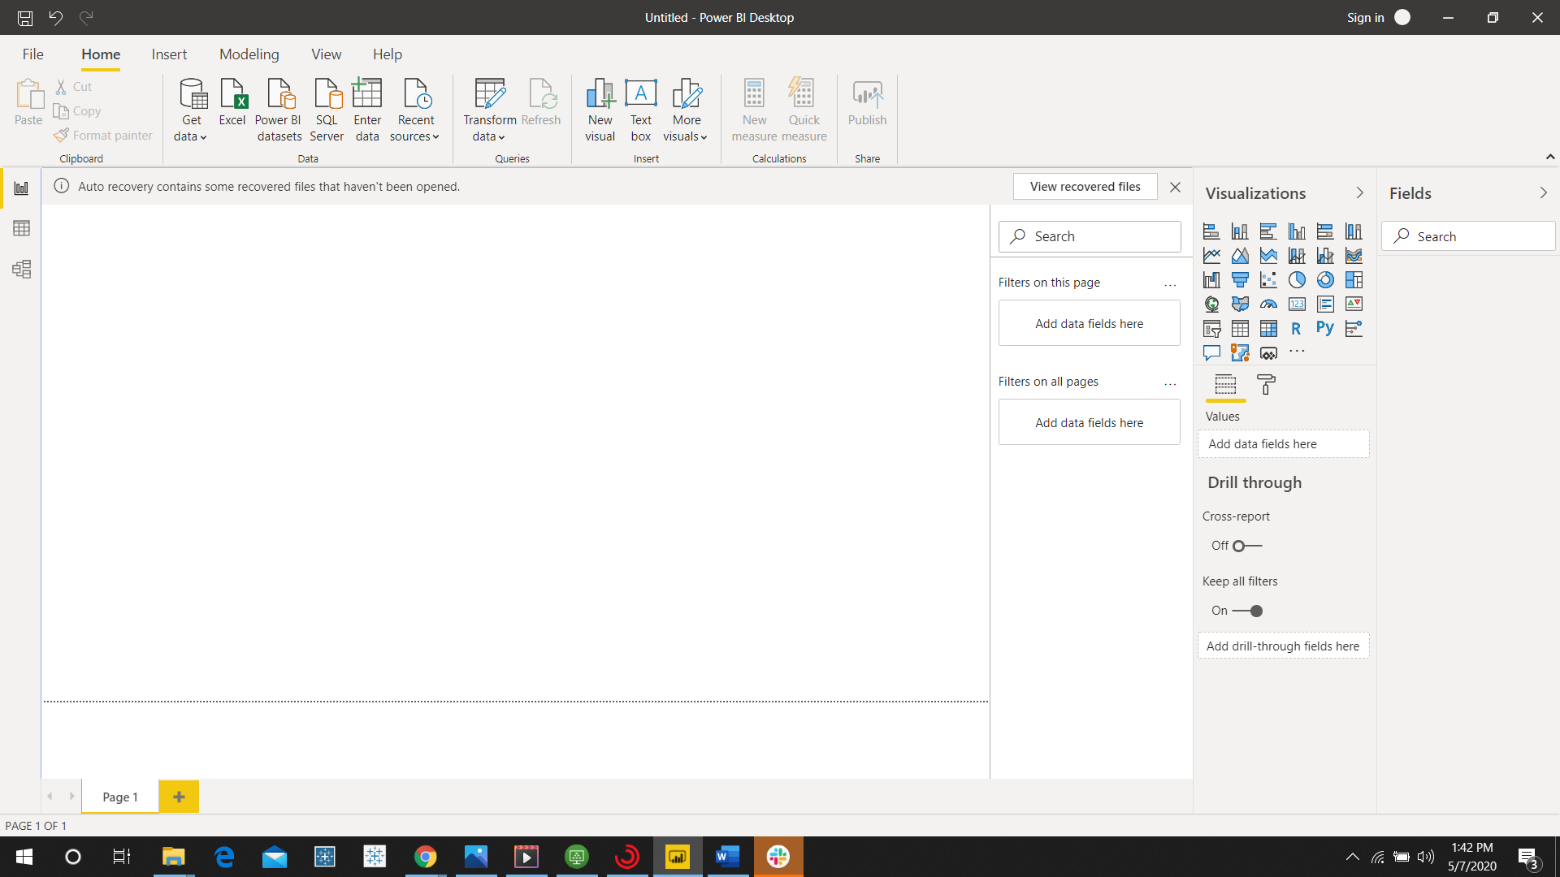

**Report View:**

Report view is used for displaying one to many visuals with the insights found.

It is like having multiple dashboards in a single view which is also interactive.



**Data view:**

This is the view obtained after the data have been loaded into the model.

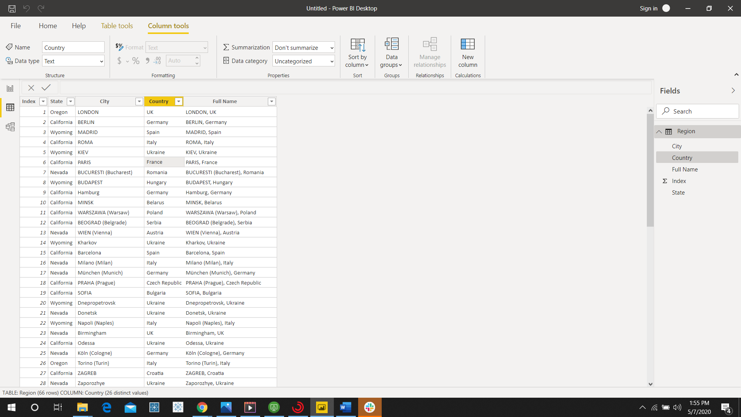

**Model view:**

It displays the table and column names.

This is used to view and setup relationship between various types of data.

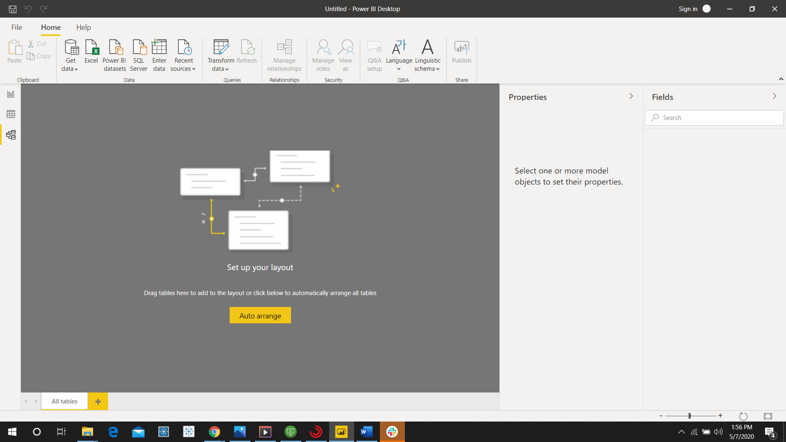

**Power query editor:**

This editor appears when the transform data is given.

This editor is used to edit and transform data before it is being loaded.

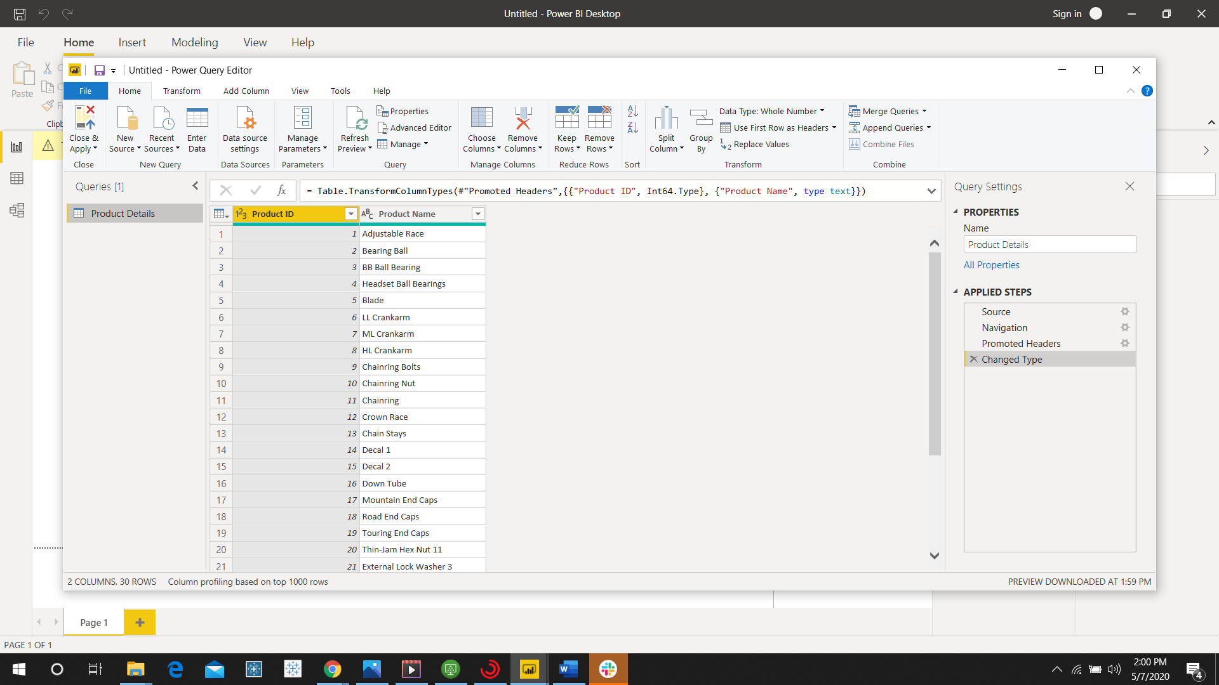

**Advanced editor:**

Advanced editor is available within power query editor.

It is used for typing and editing the query code.

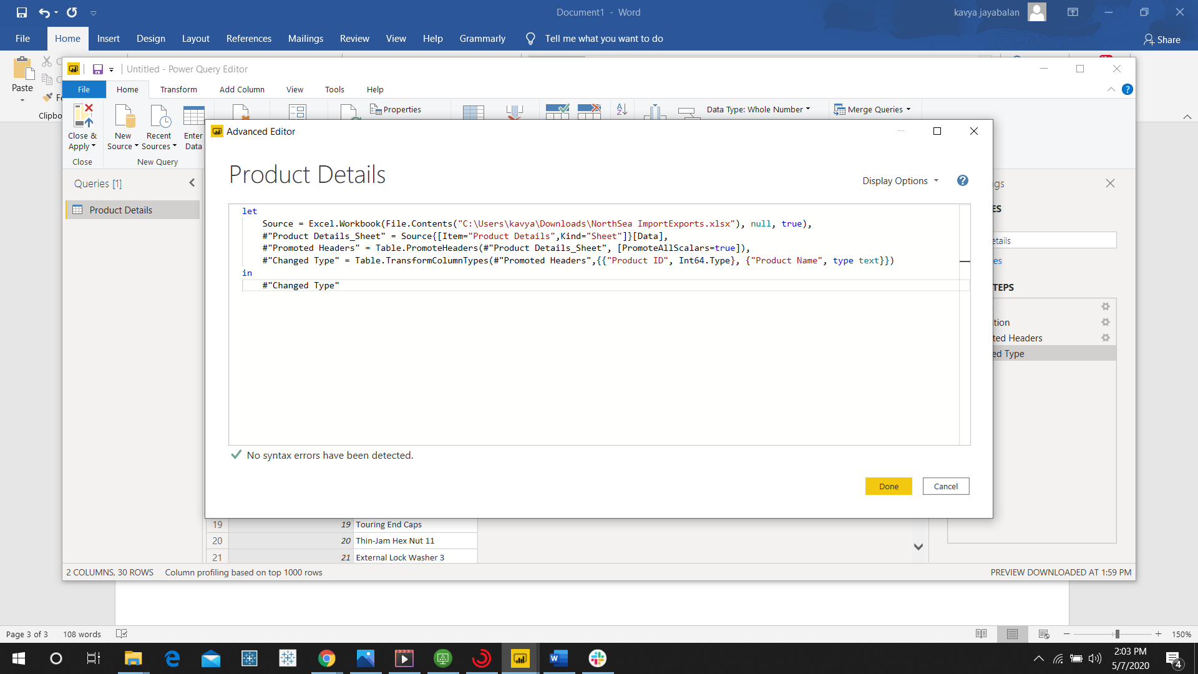

**Power BI Desktop:**

Power BI desktop is used for data analysis and report creation that can be installed for free on local computer.

Power BI desktop is a free application that lets you connect to different data sources and create data models.

The reports can be published only publicly using power bi desktop.

It includes data cleaning and preparation, custom visualizations and the ability to publish to the Power BI service.

Price: Free

**Power BI Pro:**

Power BI Pro is similar to power BI desktop because they have the same visualization options and the same limits on storage and file upload size.

The major difference is that with Pro, you can share your data, reports, and dashboards with others privately with Power BI Pro license.

Other differences:

* Ability to embed Power BI visuals into apps (PowerApps, SharePoint, Teams, etc)
* Native integration with other Microsoft solutions (Azure Data Services)
* Can create App Workspaces and peer-to-peer sharing

Each user should have a pro license.

Price:  $9.99/user/month

Free trial for 60 days before purchasing the subscription is available.

**Power BI Premium:**

Power BI Premium is the most expensive tier of Power BI currently available and very distinct from the other two versions available on the market.

Users of Power BI Premium get:

* Increased data capacity limits and maximum performance
* Access to one API surface
* Ability to embed Power BI visuals into apps (PowerApps, SharePoint, Teams, etc)
* Larger storage sizes for extended deployments
* Geo distribution, higher refresh rates, isolation, pin to memory, read-only replicas
* Power BI Report Server

The licenses are bought in a way that any number of users can use it. No need of buying individual user license.

Price: **$4,995** Monthly price per dedicated cloud compute and storage resource with annual subscription

**$4,995**

Monthly price per dedicated cloud compute and storage resource with annual subscription